* Introduction to Spark Streaming

**What is Spark Streaming?**

* **Definition:**
  + Spark Streaming is an extension of Apache Spark that enables scalable, high-throughput, fault-tolerant stream processing of live data streams.
* **Key Points:**
  + Processes real-time data streams.
  + Provides a unified platform for batch and stream processing.
  + Integrates seamlessly with Spark's core capabilities.

**How Spark Streaming Works**

* **Overview:**
  + Data is ingested in small batches (micro-batches) and processed.
  + Uses RDDs (Resilient Distributed Datasets) for batch processing.
* **Detailed Steps:**
  + **Data Ingestion:**
    - Streams are ingested from sources like Kafka, Flume, or HDFS.
  + **Micro-batching:**
    - Data is divided into batches.
  + **Processing:**
    - Each batch is processed using Spark operations.
  + **Output:**
    - Processed data is written to storage systems or dashboards.

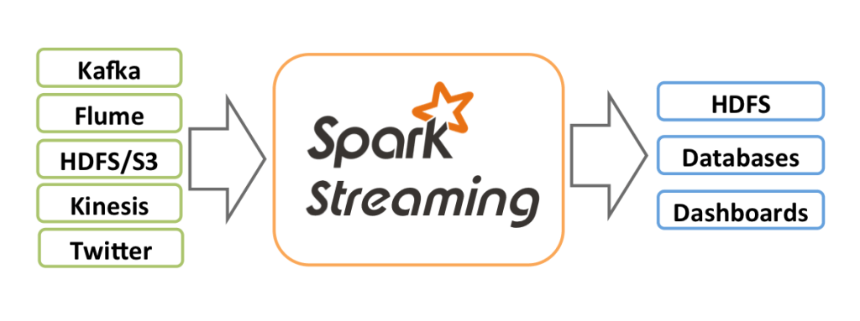

**Spark DStreams**

* **Definition:**
  + DStream (Discretized Stream) is the core abstraction in Spark Streaming.
  + Represents a continuous stream of data divided into discrete batches.
* **Key Features:**
  + Composed of a sequence of RDDs.
  + Supports transformations like map, reduce, and join.
  + Fault-tolerant and scalable.

**A Twitter Example**

* **Scenario:**
  + Real-time analysis of tweets for sentiment or trends.
* **Steps:**
  + **Data Source:**
    - Tweets are streamed via Twitter API.
  + **Streaming Application:**
    - Spark Streaming ingests tweets as a DStream.
  + **Processing:**
    - Perform sentiment analysis or trend detection using Spark's MLlib or custom algorithms.
  + **Output:**
    - Results are displayed on a dashboard or stored for further analysis.

**Fault-Tolerance in Spark Streaming**

* **Mechanism:**
  + **RDD Lineage:** Keeps track of transformations to recover lost data.
  + **Checkpointing:** Saves the state of the stream to reliable storage periodically.
* **Key Points:**
  + Enables recovery from failures by recomputing lost data using lineage information.
  + Checkpointing provides fault tolerance by saving metadata and state.

**Stateful Stream Processing**

* **Definition:**
  + Stateful processing maintains state information across batches, allowing for computations that require knowledge of past events.
* **Use Cases:**
  + Track user sessions, detect anomalies, maintain running counts.
* **Implementation:**
  + **Update State By Key:** Maintains state for each key and updates it incrementally.
  + **Stateful Operations:** Operations like updateStateByKey or mapWithState.

**Summary:**

* + Spark Streaming provides powerful capabilities for real-time data processing.
  + Combines batch and streaming data processing into a unified model.
  + Fault-tolerance and stateful processing enhance robustness and flexibility.